Study Guide

**Venous Thromboembolism (VTE)**

#### Description

This guide aims to provide a comprehensive overview of the important elements to consider in a systems-based approach to VTE prevention in an institutional setting.

**Learning Objectives**

By the end of this session you will be able to:

* + - undertake a risk assessment for VTE
    - select an appropriate method of thromboprophylaxis and prescribe thromboprophylaxis for an appropriate duration
    - understand the importance of performing root cause analyses of cases of VTE in hospitalised patients, and how to audit each of these steps

#### Introduction

The prevention of Venous Thromboembolism (VTE) in hospitalised patients is a top clinical priority in the NHS. The National VTE Prevention Programme provides a comprehensive, integrated and financially incentivised approach to prevent VTE.

#### About VTE

VTE is a common complication among hospital inpatients and contributes to longer hospital stays, morbidity, and mortality.

Virchow's triad

Thrombus formation and propagation depend on:

* The presence of abnormalities of blood flow
* Blood vessel injury
* An increase in the tendency of the blood to clot (hypercoagulability), known historically as Virchow's triad.

One or more of these factors are present in almost all hospitalised patients.

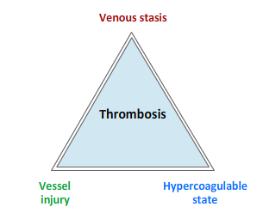

Major orthopaedic surgery

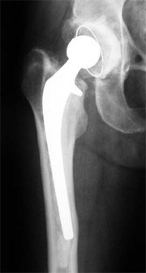Examples of patients at risk of VTE are those admitted to hospital for elective orthopaedic surgery. Venous stasis occurs after surgery, vessel wall injury is common and the surgery itself activates the coagulation system, forming a microenvironment favouring thrombus formation.

Further examples of patients at risk of VTE include most surgical patients and medical admissions if mobility is predicted to be, or is significantly reduced for, 3 or more days.

Deep vein thrombosis

VTE in hospitalised patients is:

* One of the most common complications of hospital care
* A cause of unpleasant and potentially life-threatening symptoms
* The commonest cause of preventable death Expensive to manage (investigation of suspected VTE, prolongation of hospital stay, costs of anticoagulant treatment)
* Easily prevented by undertaking a simple patient risk assessment and administering appropriate prophylaxis

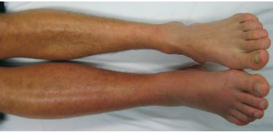

Fatal pulmonary embolism

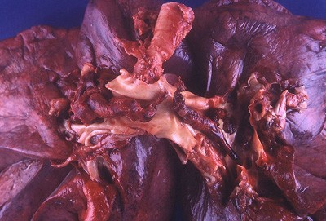

The Government has highlighted that there are too many preventable deaths from VTE in hospitalised patients, with thousands of deaths a year attributed to VTE and with a financial cost estimated to be in excess of £600 million per annum.

In 2010 the Government made VTE prevention a national clinical priority for the NHS and the national VTE Prevention Programme was put in place to help reduce the occurrence of hospital-associated VTE.

This image shows a fatal PE apparent at autopsy.

#### Prevention

#### Introduction

The Department of Health has defined hospital associated VTE as: any VTE event occurring within 90 days of hospital admission/surgery.

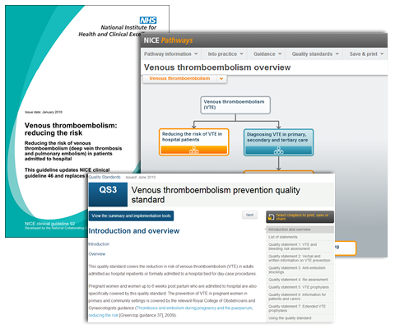The National VTE Prevention Programme provides a comprehensive, integrated and financially incentivised approach to prevent VTE. The Programme consists of:

* The NICE Clinical Guideline 92
* The NICE Quality Standard for VTE prevention
* The NICE pathway for VTE prevention
* Mandatory VTE prevention requirements set out in the NHS Standard Contract
* The national CQUIN goal for VTE prevention
* A national tool for VTE risk assessment

NICE clinical guideline 92 gives comprehensive guidance on reducing the risk of VTE in hospitalised patients and on appropriate thromboprophylaxis.

NICE VTE Prevention Quality Standard

NICE has introduced a Quality Standard that sets out seven statements of high quality VTE prevention in line with NICE Clinical Guideline 92.

The quality standards are a key part of making quality the organising principle of the NHS. They act as markers of high quality, cost effective patient care.

1. 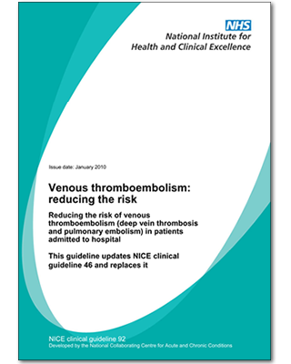All patients, on admission, receive an assessment of VTE and bleeding risk using the clinical risk assessment criteria described in the national tool
2. Patients/carers are offered verbal and written information on VTE prevention as part of the admission process
3. Patients provided with anti-embolism stockings have them fitted and monitored in accordance with NICE guidance
4. Patients are re-assessed within 24 hours of admission for risk of VTE and bleeding
5. Patients assessed to be at risk of VTE are offered VTE prophylaxis in accordance with NICE guidance
6. Patients/carers are offered verbal and written information on VTE prevention as part of the discharge process
7. Patients are offered extended (post hospital) VTE prophylaxis in accordance with NICE guidance

NICE VTE Prevention Pathway

The NICE pathway for reducing the risk of VTE in hospital patients brings together the NICE Clinical Guideline 92 and Quality Standard to support implementation of VTE prevention.

Assessing the risk of VTE is one of the first and most important steps in the pathway, fulfilling the compulsory audit requirements within the NHS and acting as the trigger to consider the need for prevention measures.

Click [here](http://pathways.nice.org.uk/pathways/venous-thromboembolism) to go to the NICE VTE Prevention Pathway.

The pathway is interactive and designed to be used online.

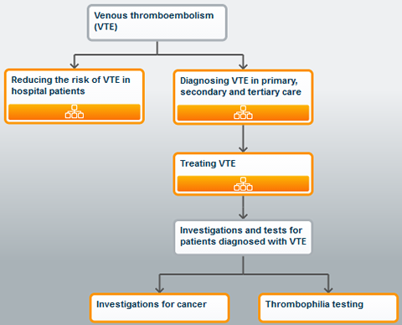

#### National Contracting of NHS Services

It is set out in the NHS Standard Contract that all acute hospitals must:

* Perform risk assessment of all patients on admission to hospital in line with NICE CG92
* Audit the percentage of patients risk assessed for VTE and those who receive appropriate thromboprophylaxis
* Perform root cause analysis of hospital-associated VTE cases that occur

#### The National CQUIN Goal For VTE Prevention

CQUIN, the Commissioning for Quality and Innovation Framework, was introduced into the NHS in 2009 as a financial incentive to improve quality of care.

A proportion of hospitals' total contract value is made conditional on the provider achieving locally agreed improvement and innovation goals. A national CQUIN goal:

**'To reduce avoidable death, disability and chronic ill health from VTE'**

has been included as part of the scheme since 2010.

The 2013/14 CQUIN sets out that acute hospitals can be paid a proportion of the CQUIN money if they:

* Risk assess at least 95% of patients for their risk of VTE on admission to hospital, using an approach compliant with the National Risk Assessment Tool, AND
* Perform a locally agreed target number of root cause analyses of cases of hospital-associated VTE

Numbers of VTE risk assessments are reported monthly and root cause analyses, quarterly.

More information on the National VTE CQUIN goal can be found on the National VTE Prevention Programme website.

#### VTE Risk Assessment

#### Introduction

Risk assessment should be undertaken using the National VTE Risk Assessment Tool.

In some Trusts, risk assessment is performed using an electronic tool, but in others the risk assessment is paper-based.

You may find that your Trust has implemented a local approach to VTE risk assessment that incorporates the elements of the National Risk Assessment Tool.

You should ensure you are familiar with your local VTE prevention policy.

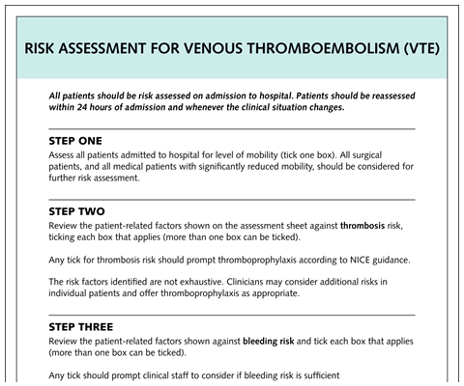

#### Step 1: Assess mobility

All surgical patients, and all medical patients with significantly reduced mobility, should be considered for further risk assessment.

If a patient is a medical admission and not expected to be immobile, a simple tick completes the risk assessment process.

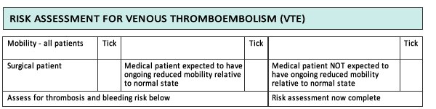

#### Step 2: Assess risk factors

Any tick in these boxes indicates that the patient is at risk of VTE. For example, a patient with hip fracture is at risk of VTE.

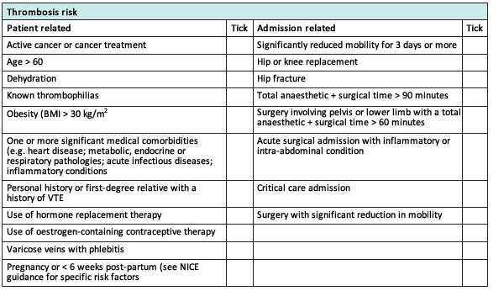

#### Step 3: Assess bleeding risk

The risk of bleeding must always be considered before prevention steps are taken. Any tick should prompt clinical staff to consider if bleeding risk is sufficient to preclude pharmacological intervention.

For example, a patient who is thrombocytopenic (platelets < 75) is at risk of bleeding.

More information on the National Risk Assessment can be found on the National VTE Prevention Programme website.

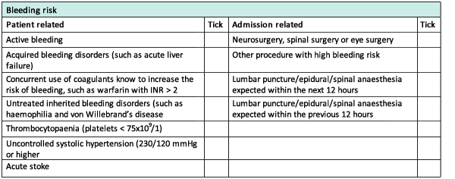

#### Root Cause Analysis

#### Introduction

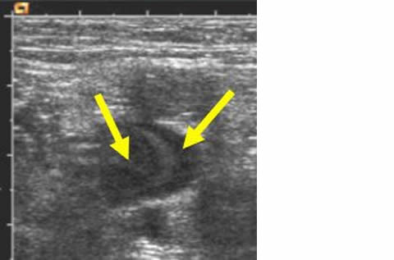

If a DVT or PE occurs while the patient is in hospital or up to 90 days from admission, then the clinical team should conduct a root cause analysis to attempt to understand why that patient suffered a thromboembolic event.

In this patient (Fig 1), ultrasound confirmed the diagnosis of DVT. The superficial femoral vein is occluded with the tongue of thrombus extending into the common femoral vein.

Such a diagnosis within 90 days of hospitalisation is classed as a hospital-associated VTE and should be reported to your local team for review and analysis.

|  |
| --- |
| **Fig 1** The superficial femoral vein is occluded |

#### What Causes Hospital-associated VTE

Root cause analysis of a VTE event provides a systematic and evidence based method of finding out what factors or events lead to a patient suffering VTE.

The results of the root cause analysis will help hospitals to:

* Gain a better understanding of the contributory factors and causes associated with VTE events
* Take action to reduce the risk of them occurring in the future

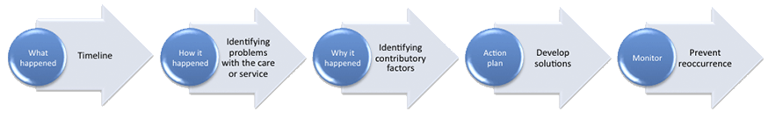

#### Identifying Hospital-associated VTE

Cases of VTE can be identified through diagnostic services (scans positive for PE or DVT), pathology (autopsy) and bereavement (death certificate data) services. Approximately half these cases might be expected to be a hospital-associated VTE.

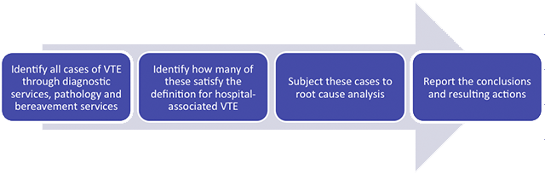

More information on the National Risk Assessment can be found on the National VTE Prevention Programme website.

#### Patient Information

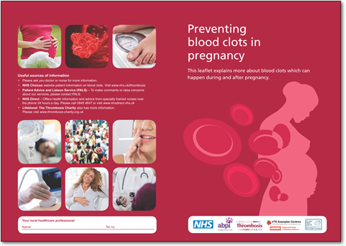A key aspect of the NICE quality standards is the need to offer patients and carers verbal and written information on VTE prevention, both at admission and as part of the discharge process.

Ensure you are familiar with your Trust's VTE information leaflet and any other patient-related communication tools.

National standard patient information leaflets are freely available to educate patients on VTE and its prevention.

Further translations of these documents can be accessed on the National VTE Prevention Programme website.

#### Thromboprophylaxis

#### Introduction

Thromboprophylaxis is defined as the use of medication or medical devices to prevent the formation of blood clots.

For all patients, three simple steps should be taken to reduce the risk of VTE:

1. Encourage mobilisation
2. Avoid dehydration
3. Reassess risk for VTE whenever clinical condition changes

For patients found to be at risk for VTE after a risk assessment, thromboprophylaxis should be prescribed.

## http://cs1.e-learningforhealthcare.org.uk/public/VTE_Public_Access/VTE_02_01/jpg/image11.jpg

## Types of Thromboprophylaxis

There are two types of thromboprophylaxis: mechanical methods and anticoagulants.

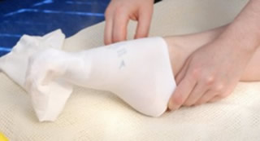The theory behind **mechanical approaches** is that they increase blood flow velocity in leg veins, reducing venous stasis. They are broadly classified as either static (anti-embolism stockings) or dynamic (intermittent pneumatic compression).

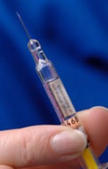**Anticoagulants** prevent the formation of a venous thrombus and/or restrict its extension by directly altering the process of blood coagulation.

The most common anticoagulants used are unfractionated heparin (UFH) and low molecular weight heparin (LMWH). For elective total hip/knee replacement, the anticoagulants rivaroxaban, dabigatran or apixaban can be used.

## Mechanical Prophylaxis

Fig 1 shows a nurse fitting anti-embolism stockings, which are an example of static mechanical prophylaxis.

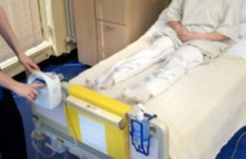Fig 2 shows a nurse starting an intermittent pneumatic compression device, which is an example of dynamic mechanical prophylaxis.

## Contraindications to Mechanical Prophylaxis

Do not offer mechanical thromboprophylaxis to patients who have:

|  |  |
| --- | --- |
| * Suspected or proven peripheral arterial disease * Peripheral arterial bypass grafting Peripheral neuropathy or other causes of sensory impairment * Any local conditions in which stockings may cause damage, for example fragile 'tissue paper' skin, dermatitis, gangrene or recent skin graft * Known allergy to material of manufacture * Cardiac failure * Severe leg oedema or pulmonary oedema from congestive heart failure * Unusual leg size or shape * Major limb deformity preventing correct fit | This patient is suffering from peripheral arterial disease and mechanical methods of thromboprophylaxis are contraindicated |

Do not use:

* Antiembolism stockings in stroke patients
* Intermittent pneumatic compression in patients with a recent DVT

Use caution and clinical judgement when applying anti-embolism stockings over venous ulcers or wounds.

## Contraindications / Caution with Anticoagulants

* Active bleeding
* Platelet count <75x109/l
* Untreated inherited bleeding disorder
* Treatment with therapeutic anticoagulation (e.g. warfarin with INR>2)
* Acquired bleeding disorder (e.g. liver disease)
* Previous heparin-induced thrombocytopenia/allergy

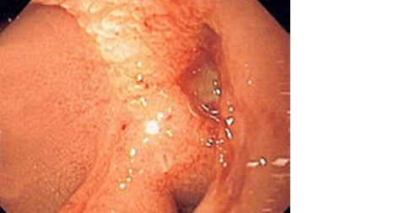

This patient is suffering from an ulcer and anticoagulants are contraindicated

## Prophylaxis after Epidural Anaesthesia

Anticoagulants must be carefully timed to reduce the risk of bleeding at the catheter site in patients undergoing epidural.

|  |  |  |
| --- | --- | --- |
| **Anticoagulant** | **Hours post dose before catheter removal / insertion** | **Hours after catheter removal / insertion before next dose** |
| **UFH** | 4h | 1h |
| **LMWH** | 12h | 4h |
| **fondaparinux** | 36h | 8h post insertion 12h post removal |
| **rivarozaban** | 18h | 6h |
| **apixaban** | 30h* | Avoid post insertion 5h post removal |
| **dabigatran** | 2-4d** | Avoid post insertion 2h post removal |

* Very limited experience; avoid if possible.   
** Timing dependent on renal function; seek local advice.

Check your local policy regarding the use of anticoagulants and spinal/epidural anaesthesia.

## Duration of Prophylaxis

The duration of prophylaxis is dependent on a patient's condition. The NICE guidelines (Guideline 92) make firm recommendations on how long it should be continued.

|  |  |
| --- | --- |
| Continue until mobility returns to normal  (see speciality specific advice to follow) | Usually 5-7 days |
| Major orthopaedic surgery  Total hip replacement/Hip fracture surgery | Continue for 28-35 days |
| Major orthopaedic surgery  Total knee replacement | Continue for 10-14days |
| Major surgery for cancer | Continue for 28-35 days |

#### Recommendations (Low Bleeding Risk)

## Introduction

## *Increased risk of VTE (Low Bleeding Risk)*

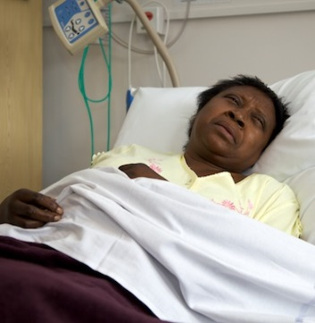

Dependent on the reason for admission, NICE recommends pharmacological prophylaxis and/or mechanical methods.

These recommendations will be covered in the following pages.

The Royal College of Obstetricians and Gynaecologists make separate recommendations for obstetric patients. Click [here](http://www.vtepreventionengland.org.uk/induction/obstetricpatients.pdf) to see them.

#### Recommendations (Low Bleeding Risk) - Medical Patients

|  |
| --- |
| General Choose any one of:   * Fondaparinux sodium * LMWH * UFH (for patients with renal failure)   Start pharmacological VTE prophylaxis as soon as possible after risk assessment has been completed. Continue until the patient is no longer at increased risk of VTE. |

|  |
| --- |
| Stroke Do not offer anti-embolism stockings for VTE prophylaxis to patients who are admitted for stroke. Consider offering prophylactic-dose LMWH (or UFH for patients with renal failure) if:   * A diagnosis of haemorrhagic stroke has been excluded, **and** * The risk of bleeding (haemorrhagic transformation of stroke or bleeding into another site) is assessed to be low, **and** * The patient has one or more of:   + Major restriction of mobility   + Previous history of VTE   + Dehydration   + Comorbidities (such as malignant disease)   Continue until the acute event is over and the patient's condition is stable.  Do not offer foot impulse or neuromuscular electrical stimulation devices for VTE prophylaxis to patients who are admitted for stroke, except in the context of research.  Consider intermittent pneumatic compression (IPC) for VTE prophylaxis in immobile patients who are admitted within 3 days of acute stroke. Explain to the patient or their family members or carers (as appropriate) that:   * It reduces the risk of deep vein thrombosis and may provide an increase in survival * It will not help them recover from stroke, and there may be an associated increased risk of surviving with severe disability   When using intermittent pneumatic compression for patients who are admitted for stroke, provide it for 30 days or until the patient is mobile or discharged, whichever is sooner. |

|  |
| --- |
| Cancer Choose any one of:   * Fondaparinux sodium * LMWH * UFH (for patients with renal failure)   Start pharmacological VTE prophylaxis as soon as possible after risk assessment has been completed. Continue until the patient is no longer at increased risk of VTE.  Do not routinely offer pharmacological or mechanical VTE prophylaxis to patients with cancer having oncological treatment who are ambulant. |

|  |
| --- |
| Palliative care Consider offering pharmacological VTE prophylaxis to patients in palliative care who have potentially reversible acute pathology.  Take into account potential risks and benefits and the views of patients and their families and/or carers.  Choose any one of:   * Fondaparinux sodium * LMWH * UFH (for patients with renal failure)   Do not routinely offer pharmacological or mechanical VTE prophylaxis to patients admitted for terminal care or those commenced on an end-of-life care pathway.  Review decisions about VTE prophylaxis for patients in palliative care daily, taking into account the views of patients, their families and/or care. |

#### Recommendations (Low Bleeding Risk) - Surgical Patients

|  |
| --- |
| **Cardiac**  Offer VTE prophylaxis to patients undergoing cardiac surgery who are not having other anticoagulation therapy and are assessed to be at increased risk of VTE. Start mechanical VTE prophylaxis at admission.  Choose any one of:   * Anti-embolism stockings (thigh or knee length) * Foot impulse devices * Intermittent pneumatic compression devices (thigh or knee length)   Continue mechanical VTE prophylaxis until the patient no longer has significantly reduced mobility.  Add pharmacological VTE prophylaxis for patients who have a low risk of major bleeding, taking into account individual patient factors and according to clinical judgement.  Choose one of:   * LMWH * UFH (for patients with renal failure)   Continue pharmacological VTE prophylaxis until the patient no longer has significantly reduced mobility (generally 5–7 days). |

**GI, gynae, thoracic and urology**

|  |
| --- |
| **Bariatric patients**  Offer VTE prophylaxis to patients undergoing bariatric surgery. Start mechanical VTE prophylaxis at admission.  Choose any one of:   * Anti-embolism stockings (thigh or knee length) * Foot impulse devices * Intermittent pneumatic compression devices (thigh or knee length)   Continue mechanical VTE prophylaxis until the patient no longer has significantly reduced mobility.  Add pharmacological VTE prophylaxis for patients who have a low risk of major bleeding, taking into account individual patient factors and according to clinical judgement.  Choose any one of:   * LMWH * UFH (for patients with renal failure)   Continue pharmacological VTE prophylaxis until the patient no longer has significantly reduced mobility (generally 5–7 days). |

|  |
| --- |
| [**Gastrointestinal patients**](http://cs1.e-learningforhealthcare.org.uk/public/VTE_Public_Access/VTE_02_01/d/ELFH_Session/578/tab_775.html)  Offer VTE prophylaxis to patients undergoing gastrointestinal surgery who are assessed to be at increased risk of VTE. Start mechanical VTE prophylaxis at admission.  Choose any one of:   * Anti-embolism stockings (thigh or knee length) * Foot impulse devices * Intermittent pneumatic compression devices (thigh or knee length)   Continue mechanical VTE prophylaxis until the patient no longer has significantly reduced mobility.  Add pharmacological VTE prophylaxis for patients who have a low risk of major bleeding, taking into account individual patient factors and according to clinical judgement.  Choose any one of:   * LMWH * UFH (for patients with renal failure)   Continue pharmacological VTE prophylaxis until the patient no longer has significantly reduced mobility (generally 5–7 days). |

|  |
| --- |
| [**Gynaecological, thoracic or urological patients**](http://cs1.e-learningforhealthcare.org.uk/public/VTE_Public_Access/VTE_02_01/d/ELFH_Session/578/tab_775.html)  Offer VTE prophylaxis to patients undergoing gynaecological, thoracic or urological surgery who are assessed to be at increased risk of VTE. Start mechanical VTE prophylaxis at admission.  Choose any one of:   * Anti-embolism stockings (thigh or knee length) * Foot impulse devices * Intermittent pneumatic compression devices (thigh or knee length)   Continue mechanical VTE prophylaxis until the patient no longer has significantly reduced mobility.  Add pharmacological VTE prophylaxis for patients who have a low risk of major bleeding, taking into account individual patient factors and according to clinical judgement.  Choose one of:   * LMWH * UFH (for patients with renal failure)   Continue pharmacological VTE prophylaxis until the patient no longer has significantly reduced mobility (generally 5–7 days).  Extend pharmacological VTE prophylaxis to 28 days postoperatively for patients who have had major cancer surgery in the abdomen or pelvis. |

|  |
| --- |
| **Neurological**  Offer VTE prophylaxis to patients undergoing cranial or spinal surgery who are assessed to be at increased risk of VTE.  Start mechanical VTE prophylaxis at admission.  Choose any one of:   * Anti-embolism stockings (thigh or knee length) * Foot impulse devices * Intermittent pneumatic compression devices (thigh or knee length)   Continue mechanical VTE prophylaxis until the patient no longer has significantly reduced mobility.  Add pharmacological VTE prophylaxis for patients who have a low risk of major bleeding, taking into account individual patient factors and according to clinical judgement.  Choose one of:   * LMWH * UFH (for patients with renal failure)   Continue pharmacological VTE prophylaxis until the patient no longer has significantly reduced mobility (generally 5–7 days).  Do not offer pharmacological VTE prophylaxis to patients with ruptured cranial or spinal vascular malformations (for example, brain aneurysms) or acute traumatic or non-traumatic haemorrhage until the lesion has been secured or the condition is stable. |

|  |
| --- |
| **Orthopaedic: elective hip replacement**  Offer combined VTE prophylaxis with mechanical and pharmacological methods to patients undergoing elective hip replacement surgery.  Start mechanical VTE prophylaxis at admission. Choose any one of the following, based on individual patient factors:   * Anti-embolism stockings (thigh or knee length), used with caution * Foot impulse devices * Intermittent pneumatic compression devices (thigh or knee length)   Continue mechanical VTE prophylaxis until the patient no longer has significantly reduced mobility.  Provided there are no contraindications, start pharmacological VTE prophylaxis after surgery. Choose any one of:   * Dabigatran etexilate, starting 1–4 hours after surgery * Fondaparinux sodium, starting 6 hours after surgical closure provided haemostasis has been established * LMWH, starting 6–12 hours after surgery * Rivaroxaban, starting 6–10 hours after surgery * UFH (for patients with renal failure), starting 6–12 hours after surgery * Apixaban, starting 12-24 hours after surgery   Continue pharmacological VTE prophylaxis for 28–35 days, according to the summary of product characteristics for the individual agent being used. |

|  |
| --- |
| **Orthopaedic:** [**elective knee replacement**](http://cs1.e-learningforhealthcare.org.uk/public/VTE_Public_Access/VTE_02_01/d/ELFH_Session/578/tab_775.html)  Offer combined VTE prophylaxis with mechanical and pharmacological methods to patients undergoing elective knee replacement surgery.  Start mechanical VTE prophylaxis at admission. Choose any one of the following, based on individual patient factors:   * Anti-embolism stockings (thigh or knee length), used with caution * Foot impulse devices * Intermittent pneumatic compression devices (thigh or knee length)   Continue mechanical VTE prophylaxis until the patient no longer has significantly reduced mobility.  Provided there are no contraindications, start pharmacological VTE prophylaxis after surgery. Choose any one of:   * Dabigatran etexilate, starting 1–4 hours after surgery * Fondaparinux sodium, starting 6 hours after surgical closure provided haemostasis has been established * LMWH, starting 6–12 hours after surgery * Rivaroxaban, starting 6–10 hours after surgery * Apixaban, starting 12-24 hours after surgery |

|  |
| --- |
| **Orthopaedic:** [**hip fracture surgery**](http://cs1.e-learningforhealthcare.org.uk/public/VTE_Public_Access/VTE_02_01/d/ELFH_Session/578/tab_775.html)  Offer combined VTE prophylaxis with mechanical and pharmacological methods to patients undergoing hip fracture surgery.  Start mechanical VTE prophylaxis at admission. Choose any one of the following, based on individual patient factors:   * Anti-embolism stockings (thigh or knee length), used with caution * Foot impulse devices * Intermittent pneumatic compression devices (thigh or knee length)   Continue mechanical VTE prophylaxis until the patient no longer has significantly reduced mobility.  Provided there are no contraindications, add pharmacological VTE prophylaxis. Choose any one of:   * Fondaparinux sodium, starting 6 hours after surgical closure, provided haemostasis has been established and there is no risk of bleeding * LMWH, starting at admission, stopping 12 hours before surgery and restarting 6–12 hours after surgery * UFH (for patients with renal failure), starting at admission, stopping 12 hours before surgery and restarting 6–12 hours after surgery   Continue pharmacological VTE prophylaxis for 28–35 days, according to the summary of product characteristics for the individual agent being used. Fondaparinux sodium is not recommended for use preoperatively for patients undergoing hip fracture surgery. If it has been used preoperatively it should be stopped 24 hours before surgery and restarted 6 hours after surgical closure, provided haemostasis has been established and there is no risk of bleeding. |

|  |
| --- |
| **Vascular**  Offer VTE prophylaxis to patients undergoing vascular surgery who are not having other anticoagulant therapy and are assessed to be at increased risk of VTE. If peripheral arterial disease is present, seek expert opinion before fitting anti-embolism stockings. Start mechanical VTE prophylaxis at admission.  Choose any one of:   * Anti-embolism stockings (thigh or knee length) * Foot impulse devices * Intermittent pneumatic compression devices (thigh or knee length)   Continue mechanical VTE prophylaxis until the patient no longer has significantly reduced mobility.  Add pharmacological VTE prophylaxis for patients who have a low risk of major bleeding, taking into account individual patient factors and according to clinical judgement.  Choose one of:   * LMWH * UFH (for patients with renal failure)   Continue pharmacological VTE prophylaxis until the patient no longer has significantly reduced mobility (generally 5–7 days). |

#### Recommendations (High Bleeding Risk)

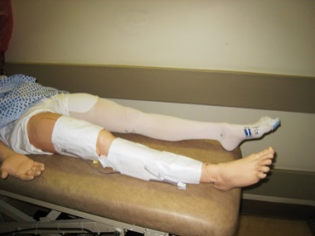NICE recommends considering mechanical methods of prophylaxis in patients with increased bleeding risk.

Choose any one of:

* Anti-embolism stockings (thigh or knee length)
* Foot impulse devices
* Intermittent pneumatic compression devices (thigh or knee length)

#### Audit of VTE Prevention

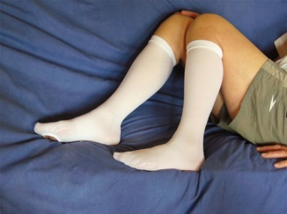Auditing the VTE prevention pathway is an important aspect of improving the quality of patient care. The elements listed should be subject to audit.

In addition, all Trusts must undertake root cause analysis of each case of hospital-associated VTE.

NHS Trusts are expected to audit the following:

* Rates of mandatory risk assessment on admission and at 24 hours
* Appropriate thromboprophylaxis rates
* Appropriate measurement and monitoring of anti-embolism stockings
* Patient counselling rates on admission and discharge

#### VTE Prevention in Primary Care



Communication between secondary and primary care of a patient is fundamental to ensure VTE prevention.

Primary care clinicians have an important role to play in:

* Managing and supporting patients discharged on extended prophylaxis
* Some primary care clinicians may also:
* Undertake VTE risk assessment of patients ahead of an elective hospital admission
* Provide patients with information on the risks of VTE and preventative treatment prior to an elective hospital admission.

#### Case Study 1

Undertake a risk assessment of this patient and select the appropriate risk category. Answers for all 3 case studies are on the last page of this document.

A 55 year old female with a 13-year history of rheumatoid arthritis, currently treated with NSAIDs, is admitted for elective hip replacement. Her haemoglobin is 12.9 g/dL and white cell count 13.5x109/L with a neutrophil leucocytosis. Platelets and electrolytes are in the normal range, as is liver function.



1. Risk Assessment

Select one option from the answers below. Answers are on the last page of this document.

|  |  |  |
| --- | --- | --- |
| A. | Low risk for VTE |  |
| B. | High risk for VTE and low risk for bleeding |  |
| C. | High risk for VTE and high risk for bleeding |  |

1. The Correct Form of Thromboprophylaxis

Select the correct form of thromboprophylaxis. Answers are on the last page of this document.

|  |  |  |
| --- | --- | --- |
| A. | Pharmacological and mechanical thromboprophylaxis continued for duration of admission |  |
| B. | Anti-embolism stockings throughout admission |  |
| C. | Pharmacological and mechanical thromboprophylaxis throughout admission and continuing for 28-35 days post-operatively |  |
| D. | Pharmacological and mechanical thromboprophylaxis throughout admission and for at least  7 days post-operatively |  |

#### Case Study 2

Undertake a risk assessment of this patient and select the appropriate risk category. Answers for all 3 case studies are on the last page of this document.

A 62 year old male is admitted with cellulitis of the upper limb, requiring intravenous antibiotics; there is no reduction in his mobility. His full blood count is normal, and his BMI is 25.

1. 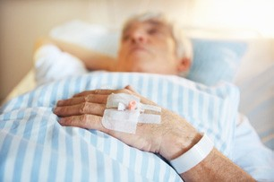Risk Assessment

Tick the box for the correct option.

|  |  |  |
| --- | --- | --- |
| A. | Low risk for VTE |  |
| B. | High risk for VTE and low risk for bleeding |  |
| C. | High risk for VTE and high risk for bleeding |  |

1. The Correct Form of Thromboprophylaxis

Tick the box for the correct option.

|  |  |  |
| --- | --- | --- |
| A. | Anti-embolism stockings throughout the admission |  |
| B. | One of LMWH or fondaparinux throughout the admission |  |
| C. | No thromboprophylaxis is required, encourage mobilisation; review VTE risk assessment whenever his clinical condition changes |  |
| D. | Either LMWH or fondaparinux and anti-embolism stockings throughout the admission |  |

#### Case Study 3 Risk Assessment

Undertake a risk assessment of this patient and select the appropriate risk category. Answers for all 3 case studies are on the last page of this document.

A 70 year old female is admitted with left sided weakness; a stroke is suspected, and an ischaemic stroke is confirmed on CT. She has a past medical history of pulmonary embolism.

1. 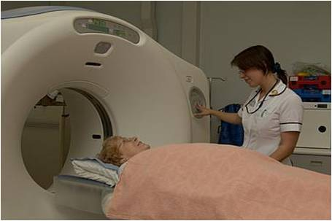Risk Assessment

Tick the box for the correct option.

|  |  |  |
| --- | --- | --- |
| A. | Low risk for VTE |  |
| B. | High risk for VTE and low risk for bleeding |  |
| C. | High risk for VTE and high risk for bleeding |  |

1. The Correct Form of Thromboprophylaxis

Tick the box for the correct option.

|  |  |  |
| --- | --- | --- |
| A. | Pharmacological and mechanical thromboprophylaxis until acute event resolved and clinical condition stabilised |  |
| B. | Antiembolism stockings until normal mobility regained |  |
| C. | Consider the risk of haemorrhagic transformation (bleeding into area of ischaemia) and if low prescribe pharmacological thromboprophylaxis until acute event resolves and patient's clinical condition stabilises |  |
| D. | Antiembolism stockings and if low risk of haemorrhagic transformation (bleeding into area of ischaemia) prescribe pharmacological thromboprophylaxis until acute event resolved and patient's clinical condition stabilises |  |

#### Session Summary

## Key Points

In this session you have looked at:

* The guidelines associated with VTE prevention
* What is required to achieve the National CQUIN goal for VTE prevention
* How to assess patients for their risk of VTE
* How to perform a root cause analysis of a VTE event
* The provision of appropriate information on VTE prevention to patients
* The different types of thromboprophylaxis and how they relate to and endeavour to prevent the formation of VTE
* How the different methods of thromboprophylaxis are used in different population groups at risk of VTE
* How to identify which steps of the VTE prevention pathway are necessary to audit
* The role of primary care in VTE prevention

## Learning Objectives

Having completed this session you will be able to:

* Undertake a risk assessment for VTE
* Select an appropriate method of thromboprophylaxis and prescribe thromboprophylaxis for an appropriate duration
* Explain the importance of performing root cause analysis of a hospital-associated

#### Case Study Answers

**Case Study 1**

**B. Correct. High risk for VTE and low risk for bleeding**

**C. Correct. This patient is undergoing a high risk orthopaedic procedure and therefore should be given both chemical and mechanical thromboprophylaxis. An extended duration of thromboprophylaxis following total hip replacement is recommended.**

**Case Study 2**



**A. Correct. Low risk for VTE**

**C. Correct. As this patient's mobility is normal, he remains at low risk for VTE. However if his clinical condition changes and mobility becomes reduced, his risk should be reassessed.**

**Case Study 3**

**C. Correct. High risk for VTE and high risk for bleeding**

**C. Correct. The patient is at high risk for VTE given her age and immobility; however, there may be a risk of haemorrhagic transformation following ischaemic stroke depending on the size and location of the infarct. Antiembolism stockings are not recommended in stroke patients due to a lack of established efficacy and the risk of skin damage associated with their use.**